IFO REC BIN

Home - Personal - Microsoft​ Edge
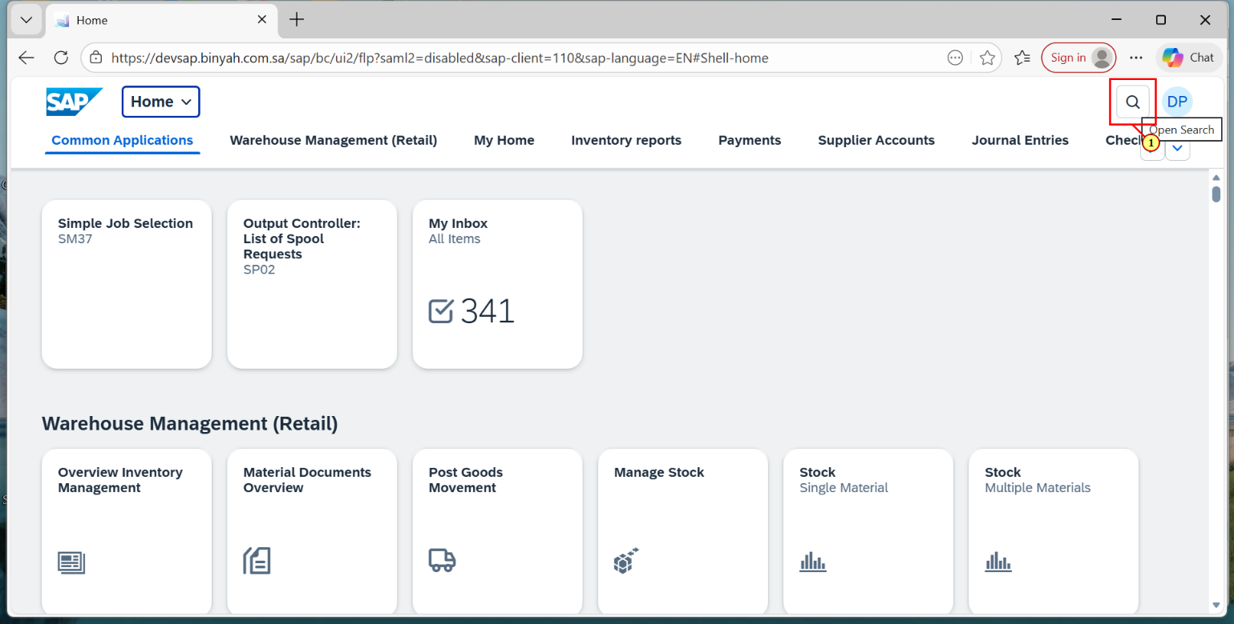
Step | Action
(1) | Click on Search Icon.

Home - Personal - Microsoft​ Edge
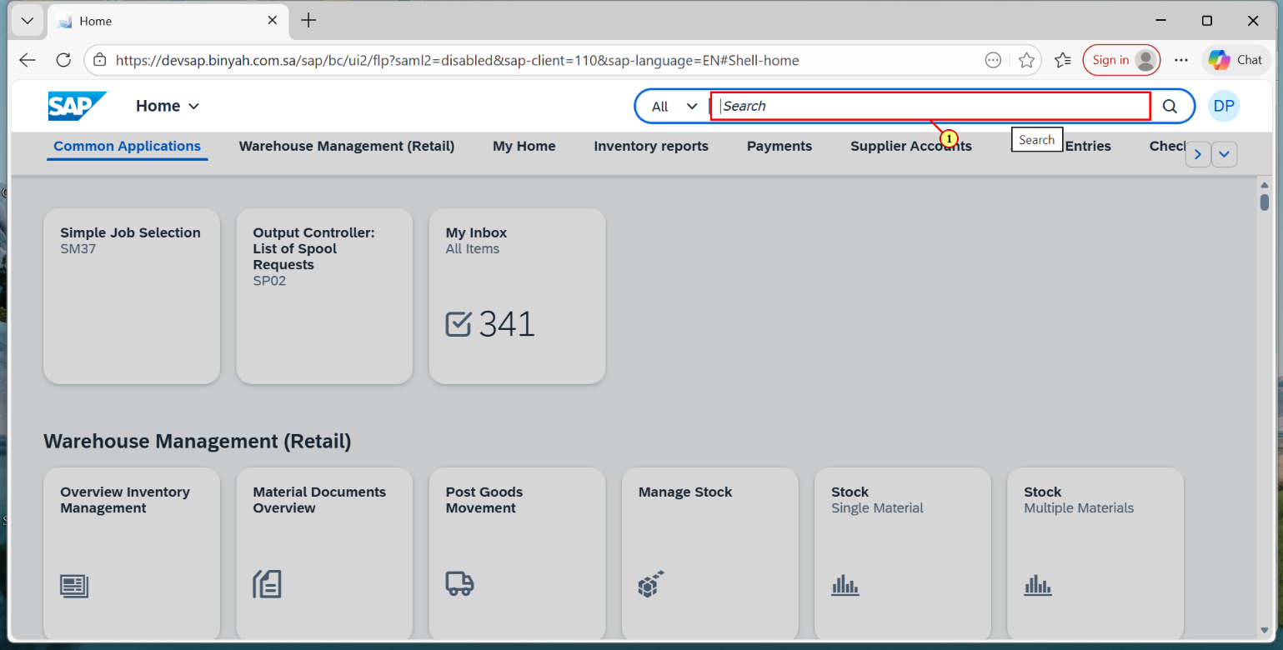
Step | Action
(1) | Enter "MANAGE PURCHASING INFO RECORD".

Home - Personal - Microsoft​ Edge
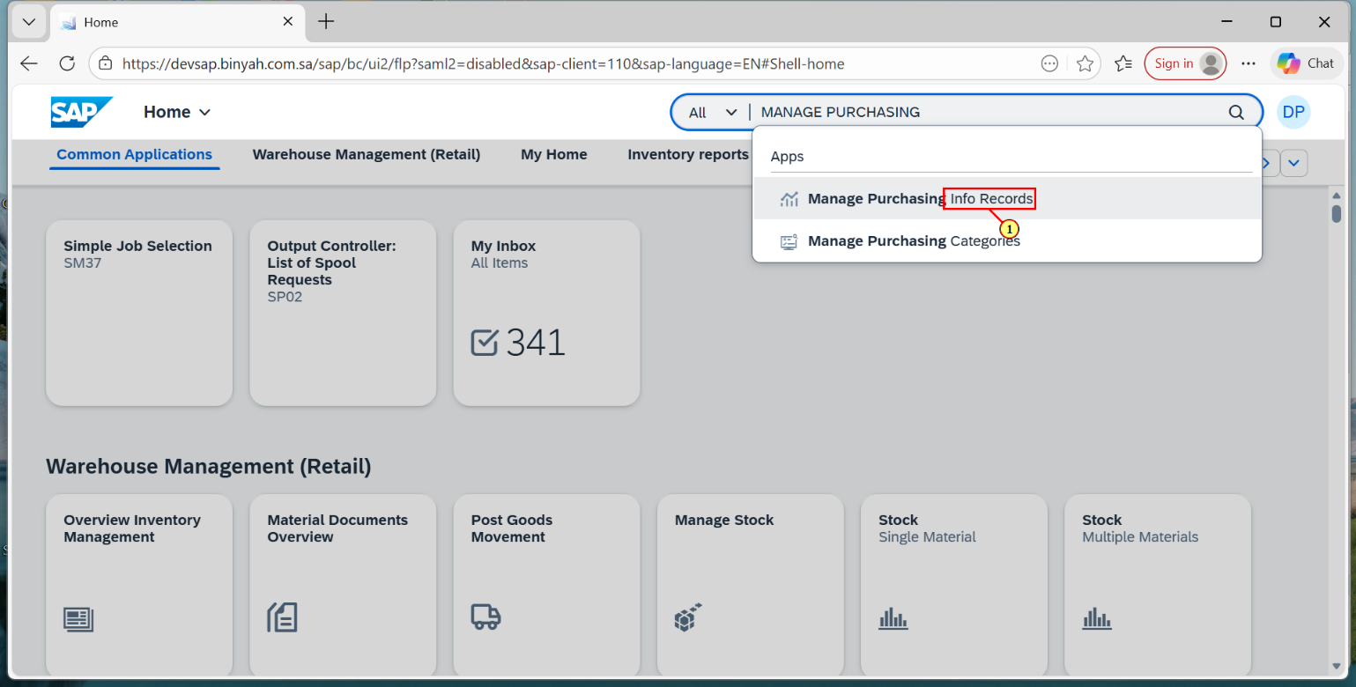
Step | Action
(1) | Select "MANAGE PURCHASING INFO RECORD".

Manage Purchasing Info Records - Personal - Microsoft​ Edge
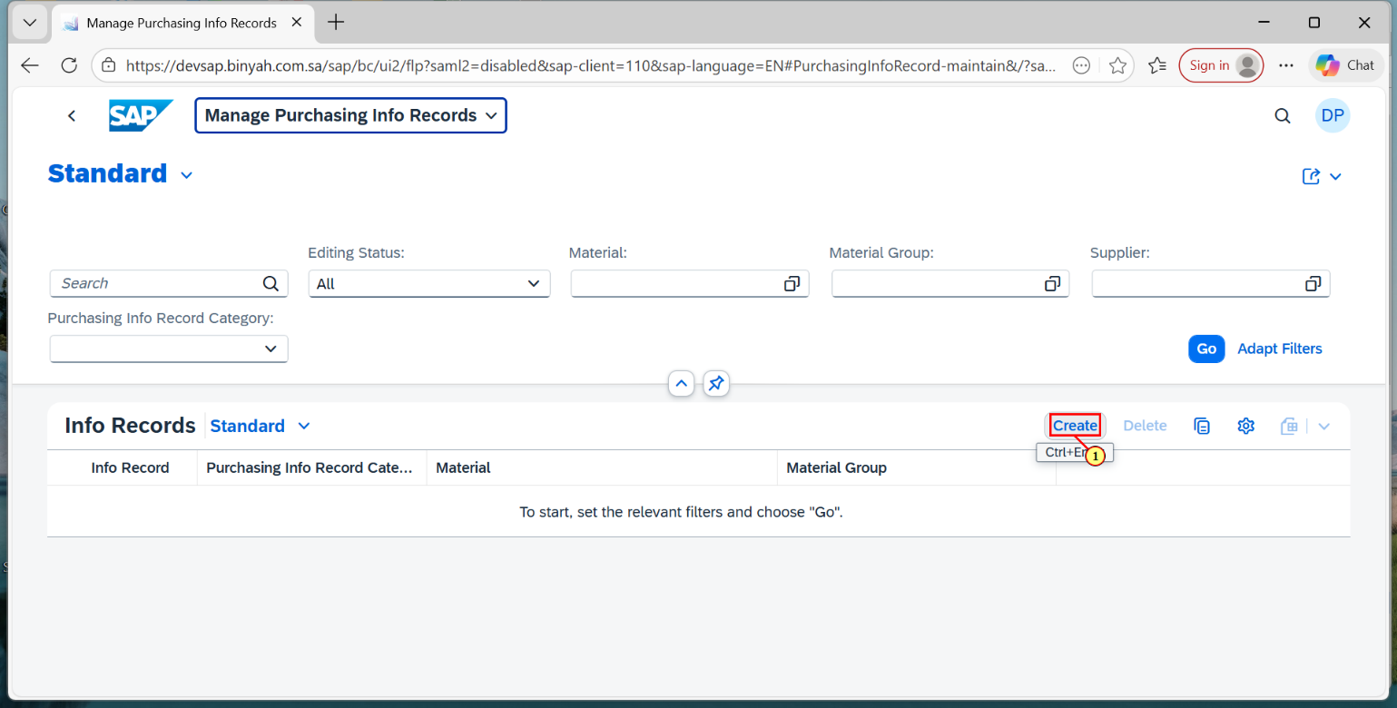
Step | Action
(1) | Click on "Create".

Purchasing Info Record - Personal - Microsoft​ Edge
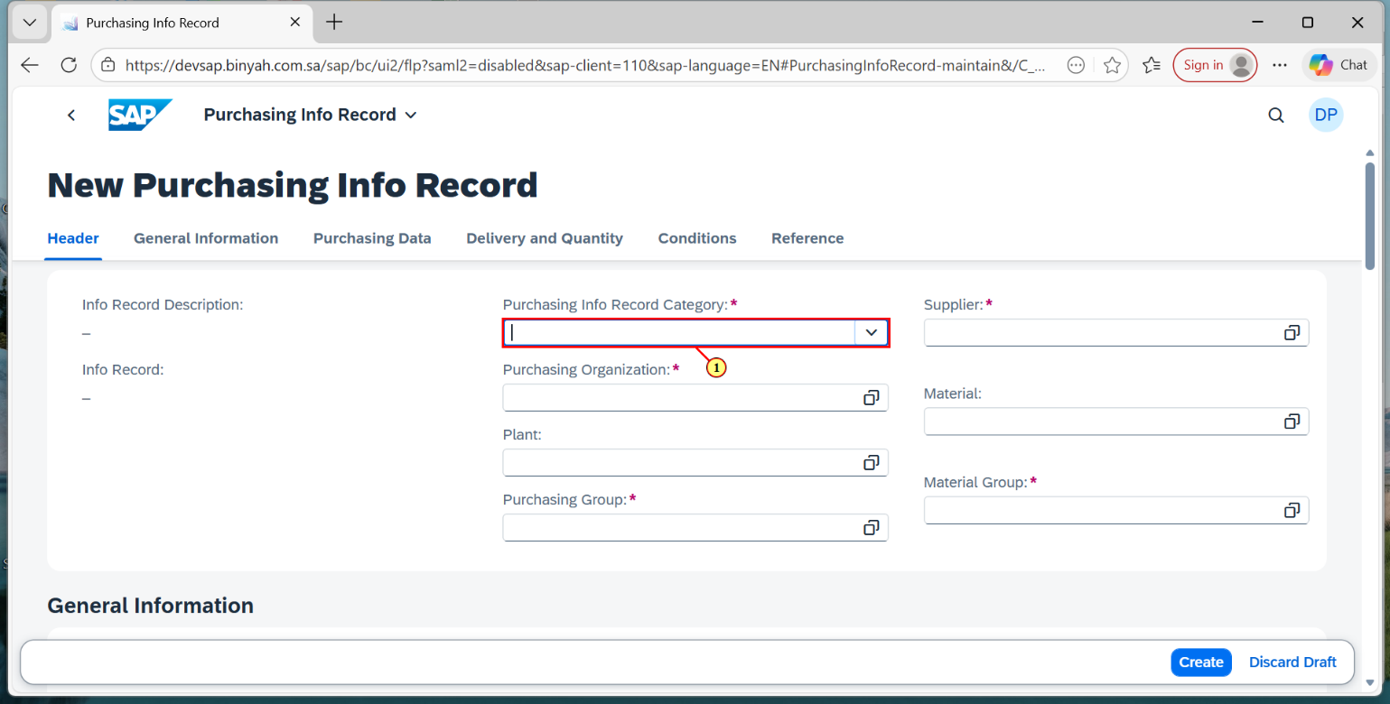
Step | Action
(1) | Enter "Purchasing Info Record Category" as "Standard".

Purchasing Info Record - Personal - Microsoft​ Edge
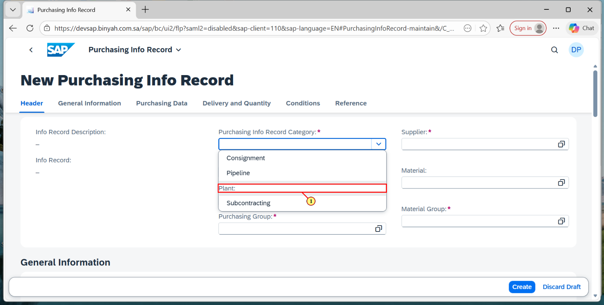
Step | Action
(1) | Choose "Standard".

Purchasing Info Record - Personal - Microsoft​ Edge
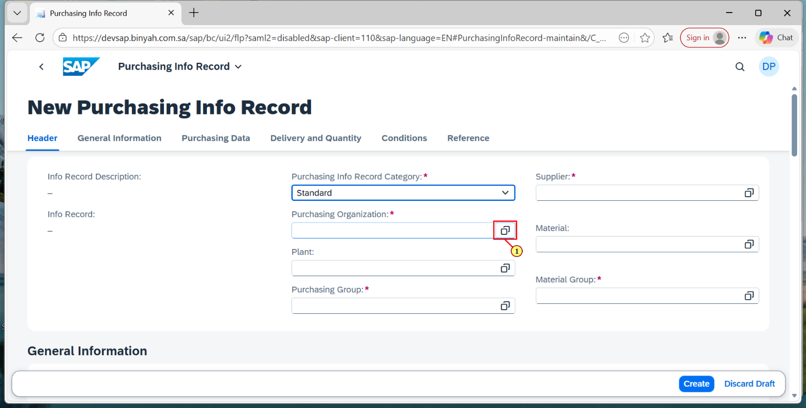
Step | Action
(1) | Enter the "Purchase Organization".

Purchasing Info Record - Personal - Microsoft​ Edge
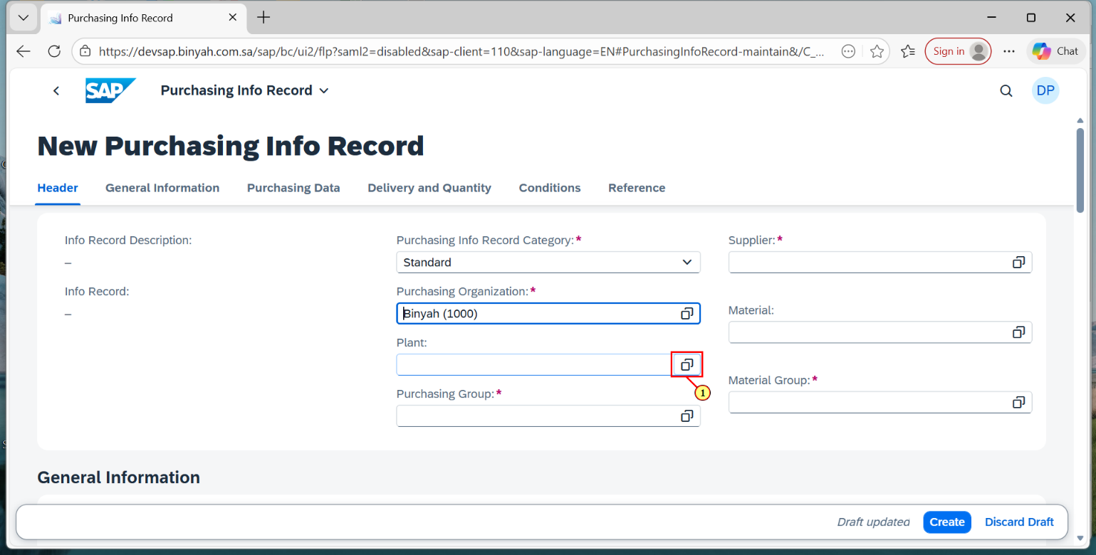
Step | Action
(1) | Enter "Plant".

Purchasing Info Record - Personal - Microsoft​ Edge
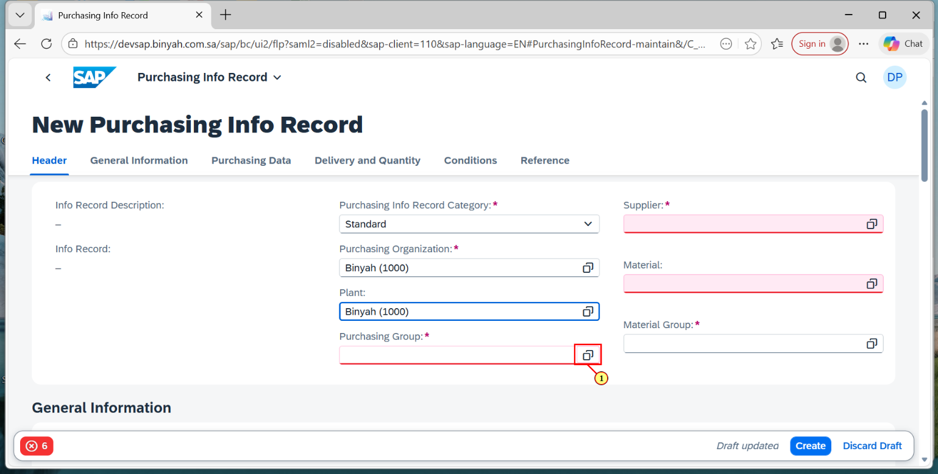
Step | Action
(1) | Enter "Purchasing Group".

Purchasing Info Record - Personal - Microsoft​ Edge
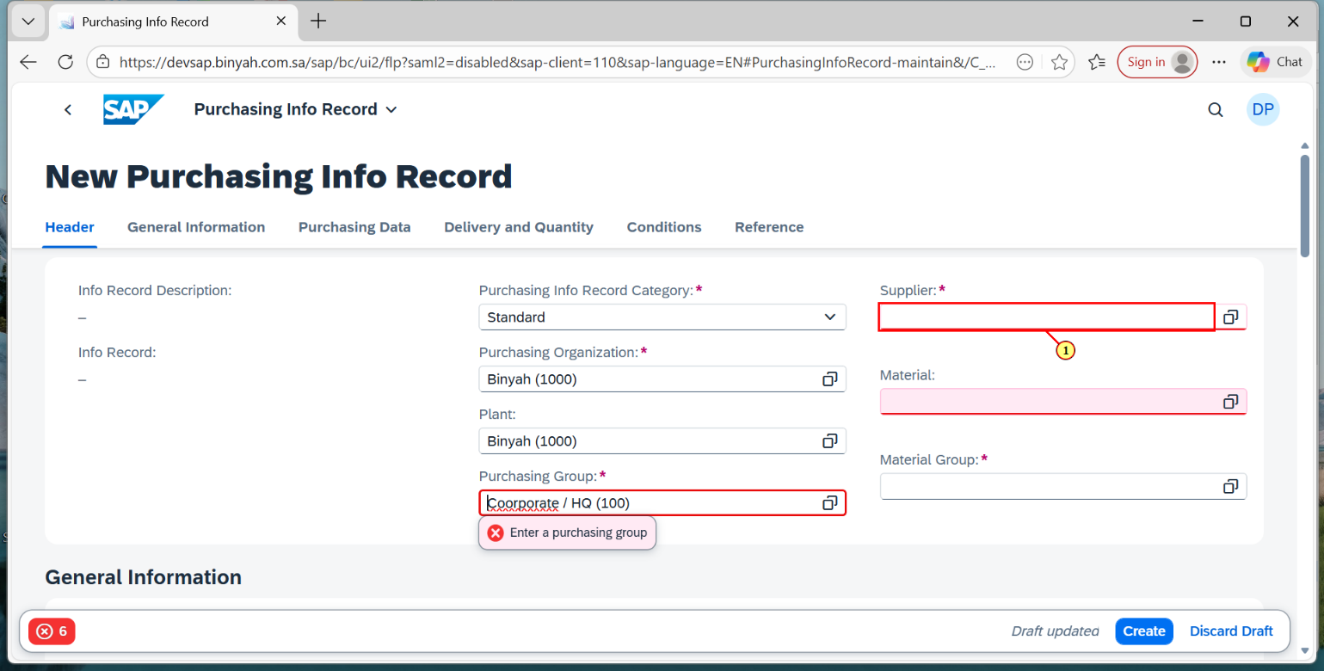
Step | Action
(1) | Enter "Supplier".

Purchasing Info Record - Personal - Microsoft​ Edge
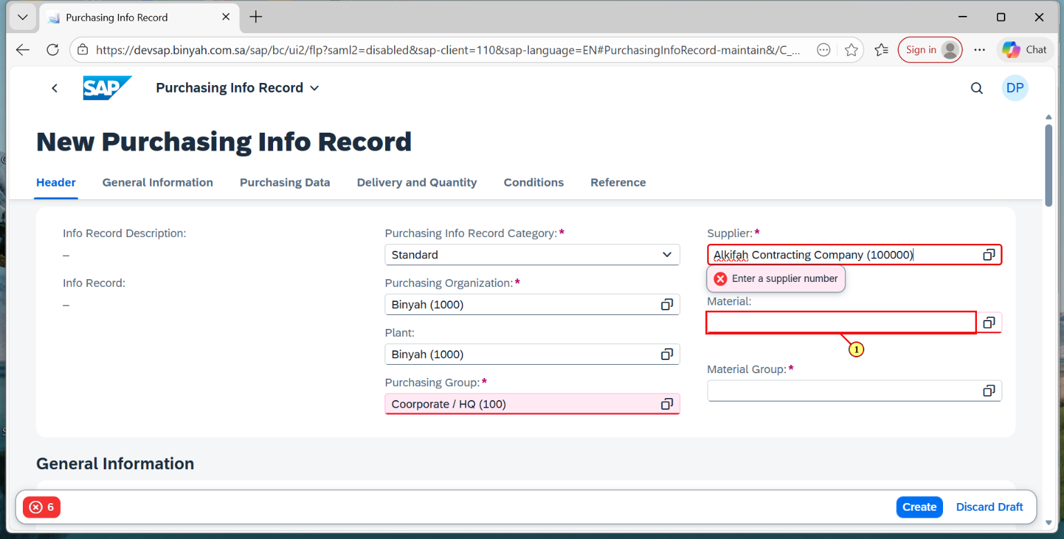
Step | Action
(1) | Enter "Material".

Purchasing Info Record - Personal - Microsoft​ Edge
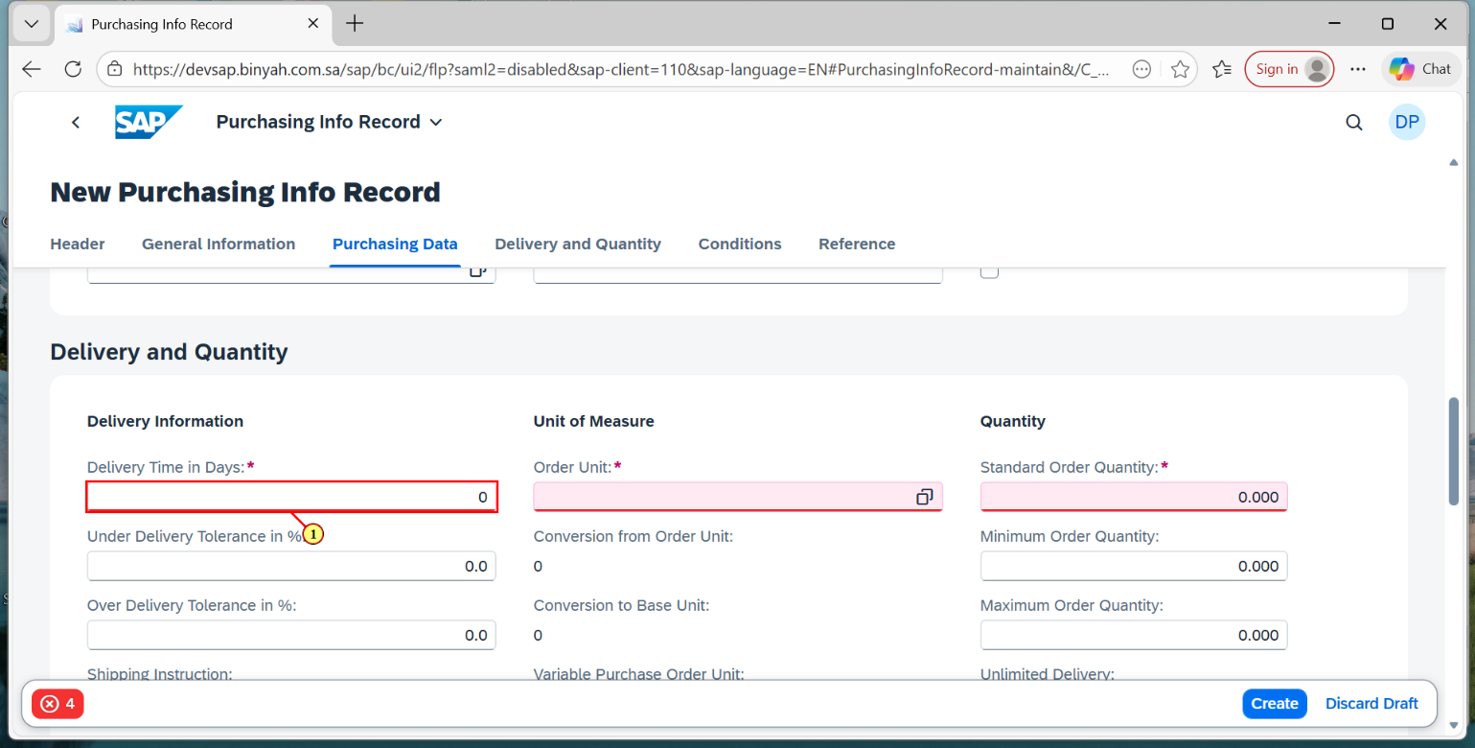
Step | Action
(1) | Scroll down to "Delivery and Quantity" section and Enter "Delivery Time".

Purchasing Info Record - Personal - Microsoft​ Edge
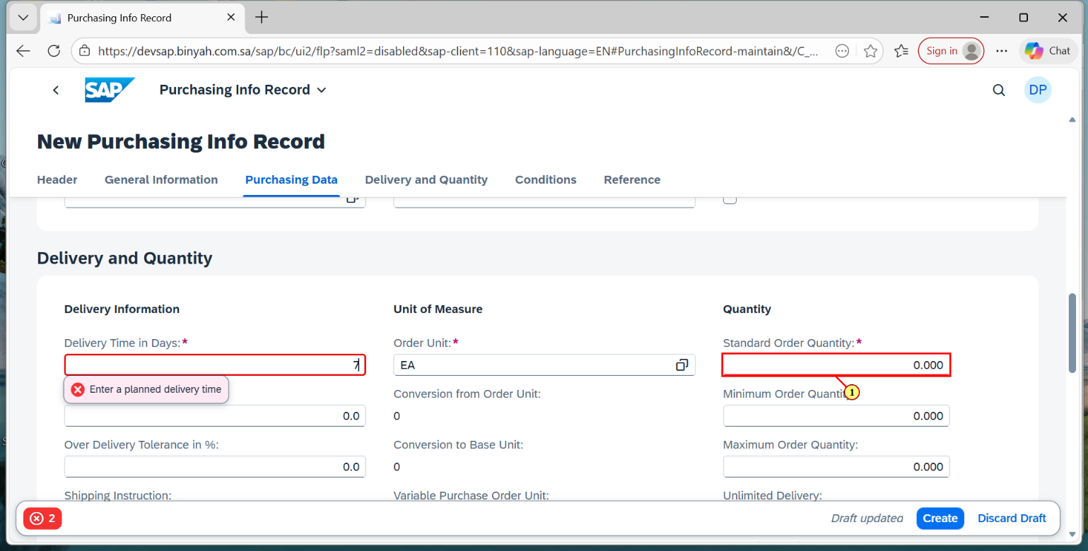
Step | Action
(1) | Enter "Standard Order Quantity".

Purchasing Info Record - Personal - Microsoft​ Edge
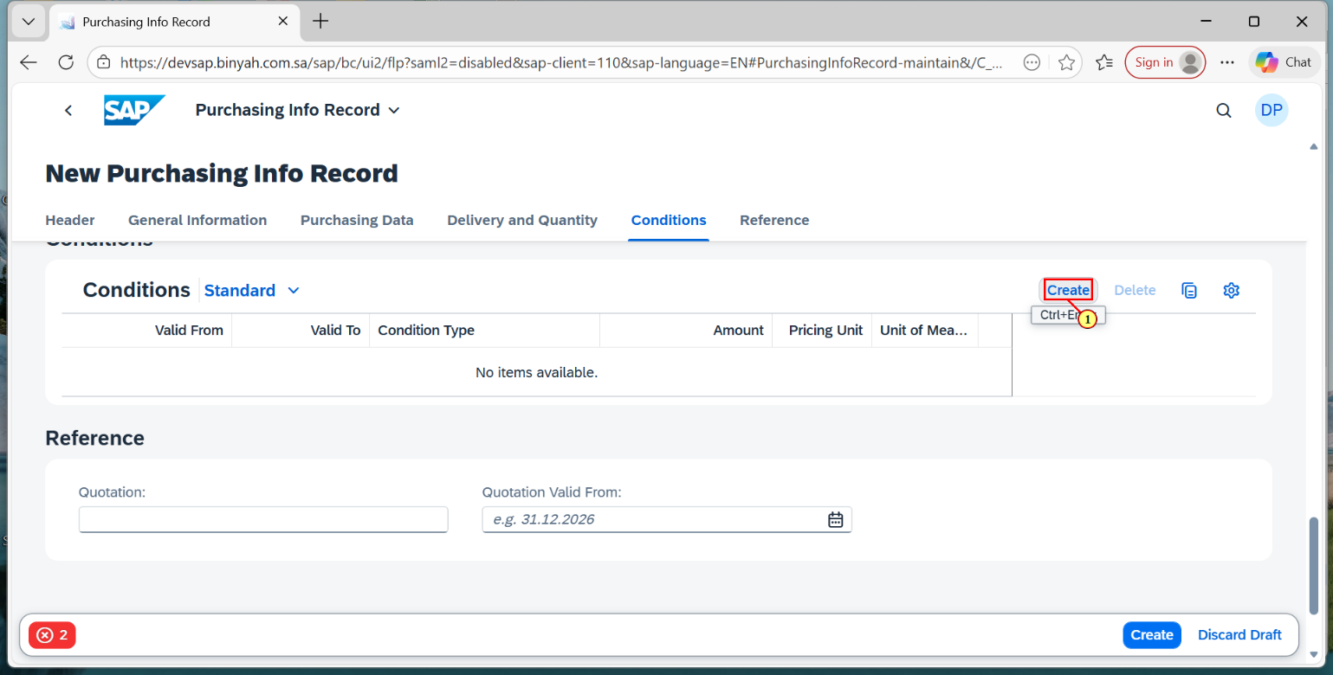
Step | Action
(1) | Scroll down to Conditions Section and click "Create".

Condition - Personal - Microsoft​ Edge
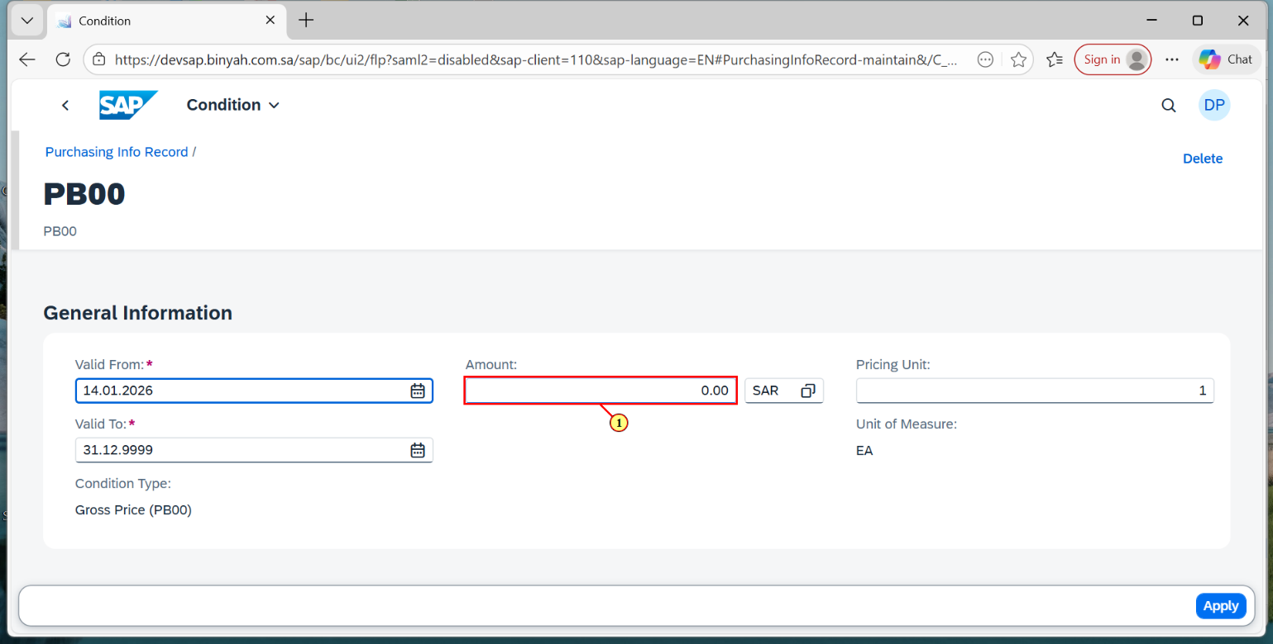
Step | Action
(1) | Select Validity and Enter "Amount".

Condition - Personal - Microsoft​ Edge
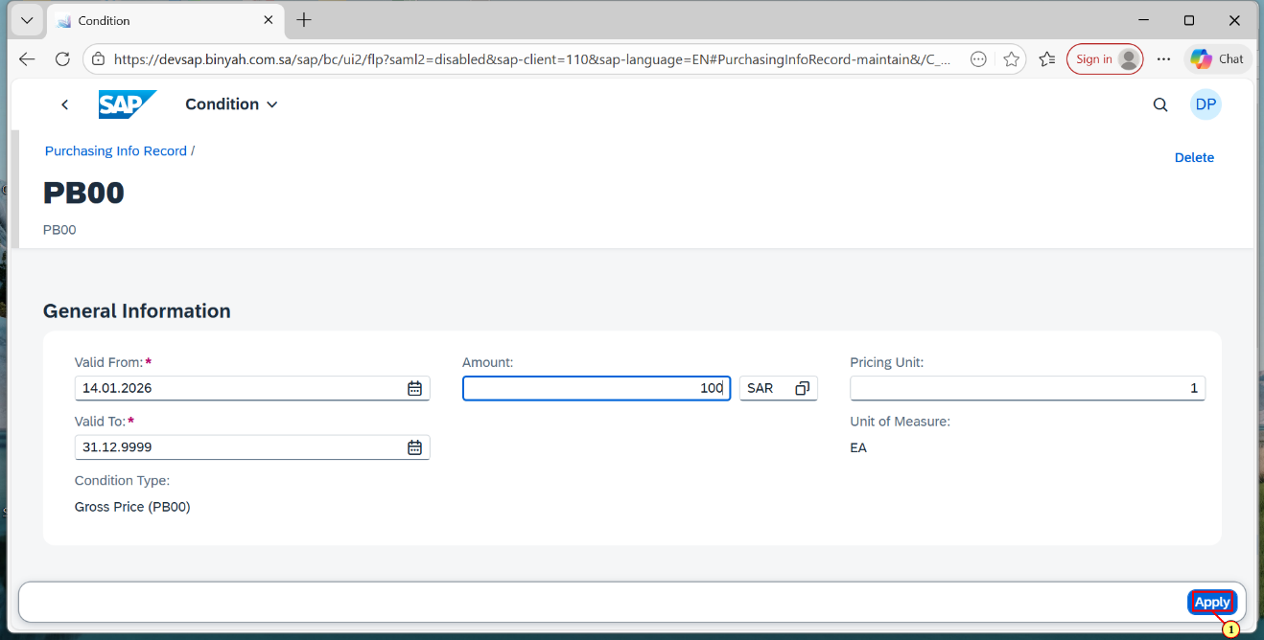
Step | Action
(1) | Click "Apply"and Click "Create".

Purchasing Info Record - Personal - Microsoft​ Edge
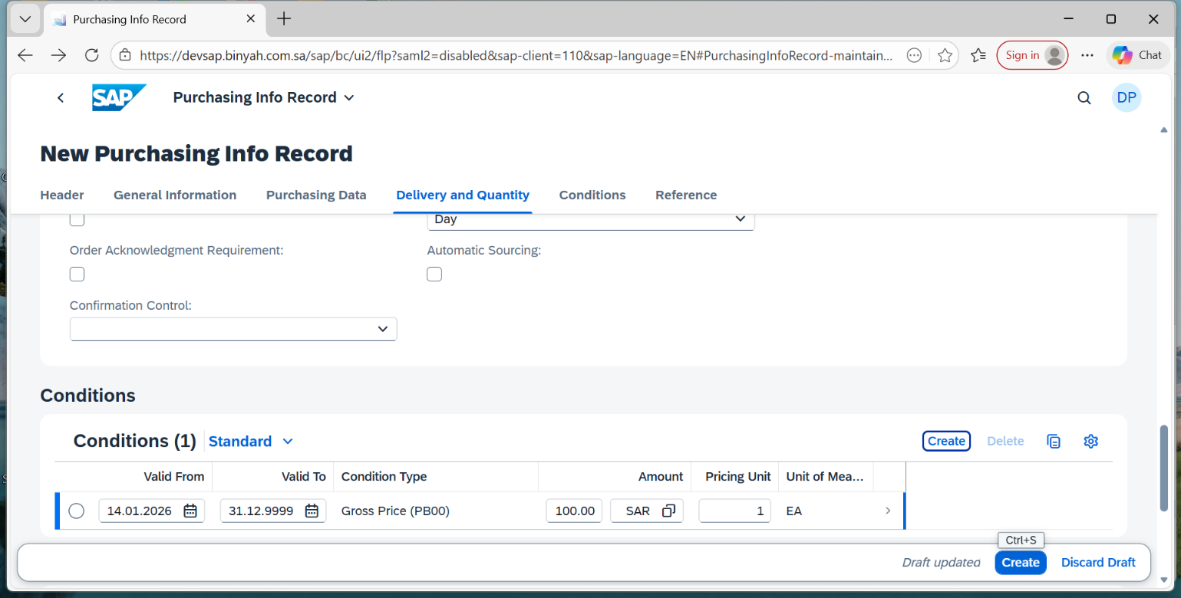
(1) | “PURCHASE INFO RECORD WAS CREATED”

